Public and Private IP Addresses

Private Addresses

1. Earlly network design when global end-to-end connectivity was envisioned for communications with all Internet hosts, intended that IP addresses be globally unique. However, it was found that this was not always necessary as private networks developed and public address space needed to be conserved.
2. Computers not connected to the Internet, such as factory machines that communicate only with each other via TCP/IP, need not have globally unique IP addresses. Today, such private networks are widely used and typically connect to the Internet with network address translation (NAT) when needed

Private IP Addresses

1. Hosts that do not require access to the Internet can use private addresses
   1. 10.0.0.0 to 10.255.255.255 (10.0.0.0/8)
   2. 172.16.0.0 to 172.31.255.255 (172.16.0.0/12)
   3. 192.168.0.0 to 192.168.255.255 (192.168.0.0/16)
2. The aforementioned are the three non-overlapping ranges of IPv4 addresses for private networks are reserved.

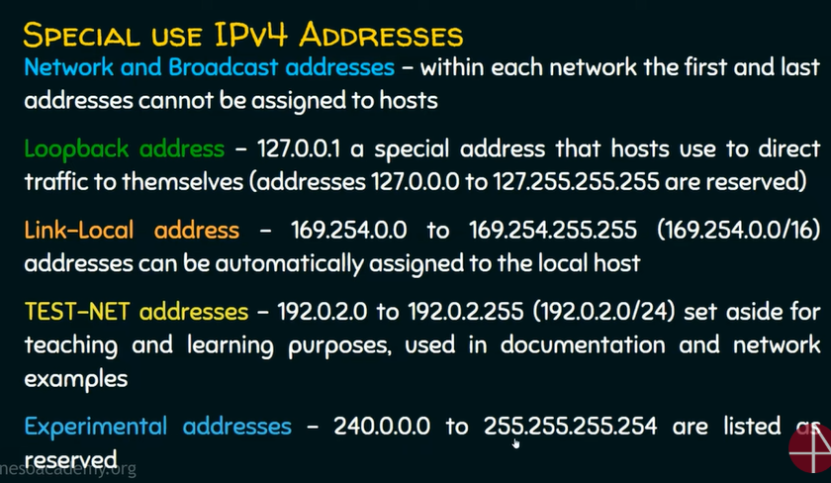

In a nutshell

1. Private IP address is used to communicate within the same network. Using private IP data or information can be sent or received within the same network.
2. Public IP address is used to communicate outside the network. Public IP address is basically assigned by the Internet Service Provider (ISP)